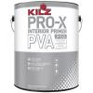
KILZ PRO-X 1-gal. PVA Primer
Model # PX01001
Quantity 4
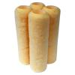
Linzer 9 in. x 3/8 in. All Paints Roller Covers (4-Pack)
Model # HD RS 93384
Quantity 1
Ralph Lauren 1-qt. British Oak Flat Interior Paint
Model # RL1302-04F
Quantity 1
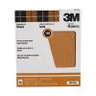
Pro-Pak 9 in. x 11 in. 120C Grit Coarse Garnet Sandpaper (25-Pack)
Model # 88619 Quantity 1

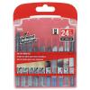
24 pc Jig Saw Blade Set
Model # 30048 Quantity 1
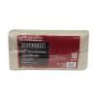
Trimaco 6 ft. x 9 ft. 10-oz. Canvas Drop Cloth
Model # 51829/6HD Quantity 1
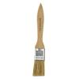
Wooster 1 in. Chip Brush
Model # 0011170010 Quantity 7

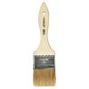
Linzer 2 in. Chip Brush
Model # 1500-2 Quantity 7
Linzer 2 in. Flat Foam Brush
Model # 8500-2 Quantity 10
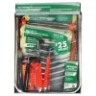
Linzer 8-Piece Roller Tray Set
Model # RS 701 SP

Colorhouse 1-qt. Nourish .06 Eggshell Interior Paint
Model # 682562 Quantity 2
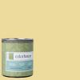
Colorhouse 1-qt. Aspire .03 Eggshell Interior Paint
Model # 682135 Quantity 1
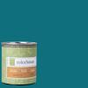
Colorhouse 1-qt. Dream .06 Flat Interior Paint
Model # 681367 Quantity 1
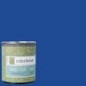
Colorhouse 1-qt. Petal .05 Eggshell Interior Paint
Model # 662557 Quantity 1
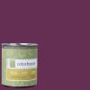
Colorhouse 1-qt. Petal .07 Semi-Gloss Interior Paint
Model # 663578 Quantity 1
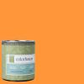
Colorhouse 1-qt. Create .02 Eggshell Interior Paint
Model # 682227 Quantity 1
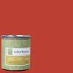
Colorhouse 1-qt. Petal .06 Semi-Gloss Interior Paint
Model # 663561 Quantity 1
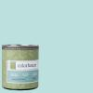
Colorhouse 1-qt. Dream .02 Eggshell Interior Paint
Model # 682326 Quantity 1
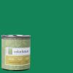
Colorhouse 1-qt. Thrive .06 Semi-Gloss Interior Paint
Model # 683668
Quantity 1
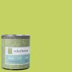
Colorhouse 1-qt. Petal .02 Eggshell Interior Paint
Model # 662526
Quantity 1
Underlayment (Common: 7/32 in. x 4 ft. x 8 ft.; Actual: 0.196 in. x 48 in. x 96 in.)
Model # 431178
Quantity 10

